

USER GUIDE

**ONLINE INSURANCE**

**ACCP 2.0 (Batch: NK_2202G1)**

*Project Instructor*

**Sir Muhammad Muneeb Ullah Khan**

Submitted by:

**Abdullah Student1359157**

**Adeen Ahmed khan Student1355497**

**Muhammad Faiq Haider Student1357930**

**Mohsin Hassan Khan Student** **1368471**

**Snap Shots of website:**

**“Section 1: Log In page & Register Page”**





**CUSTOMER:**

**“Section 2: Customer Home Page”**







**“Section 3: Insurance Plans”**

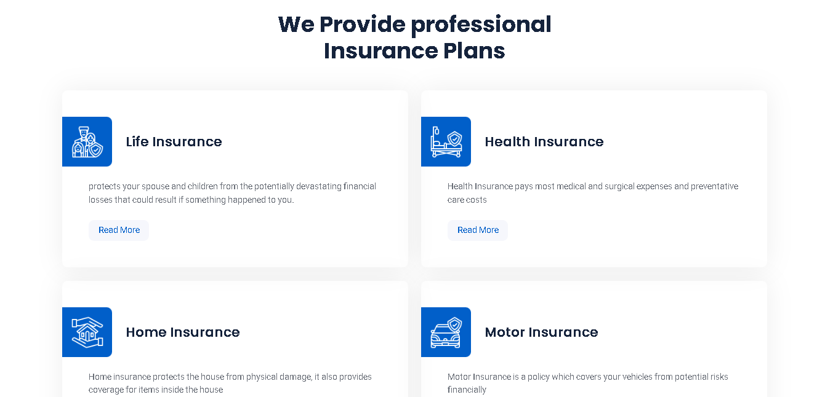

**And after click on read more on every insurance read more button you go to that insurance details page**

**“LIFE INSURANCE DETAILS PAGE”**

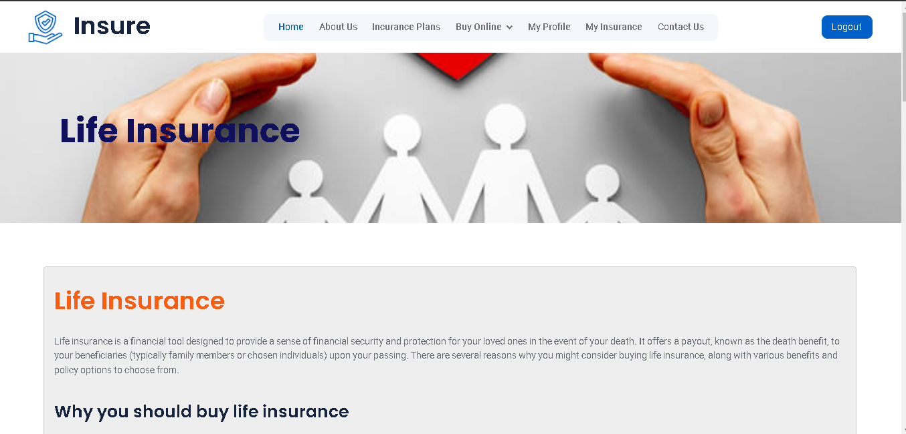

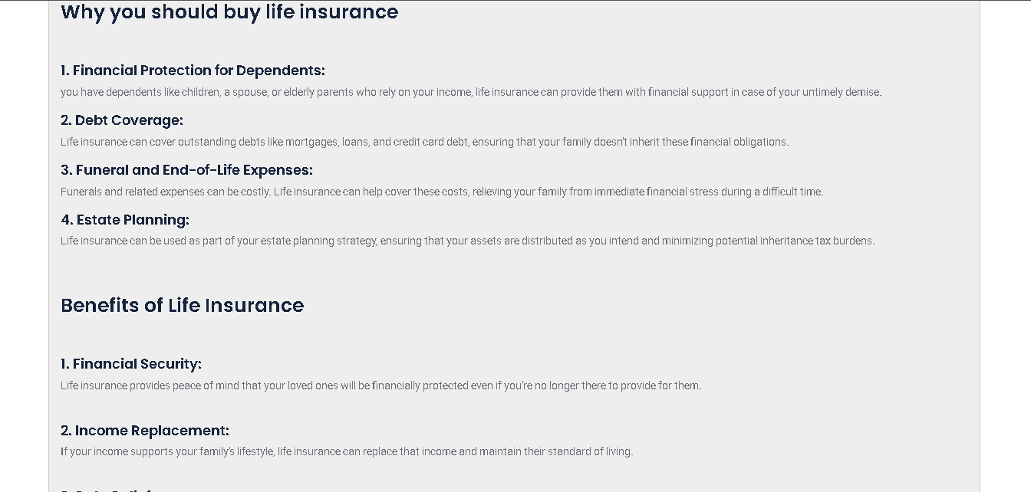

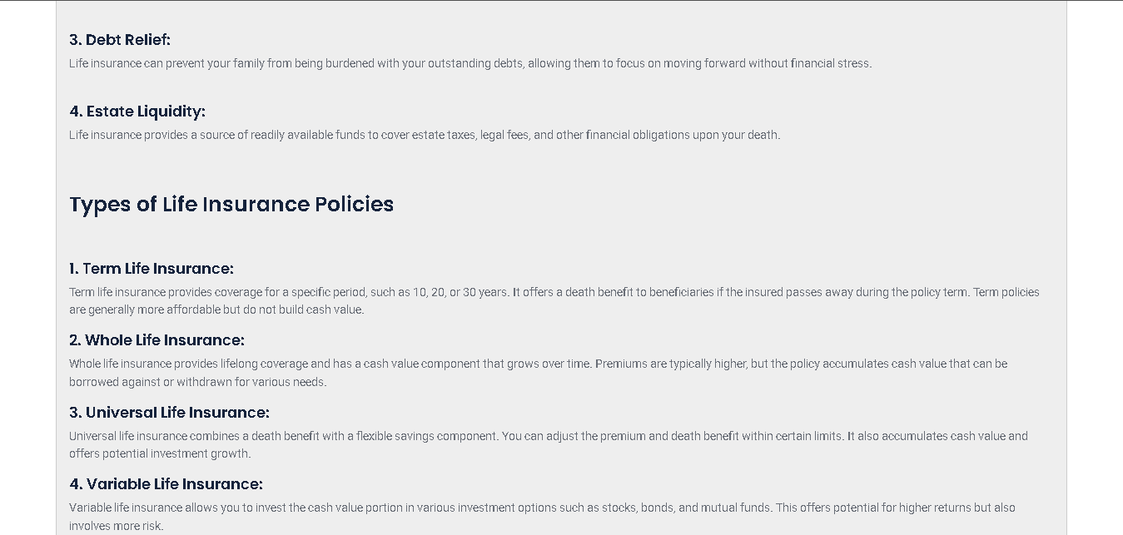

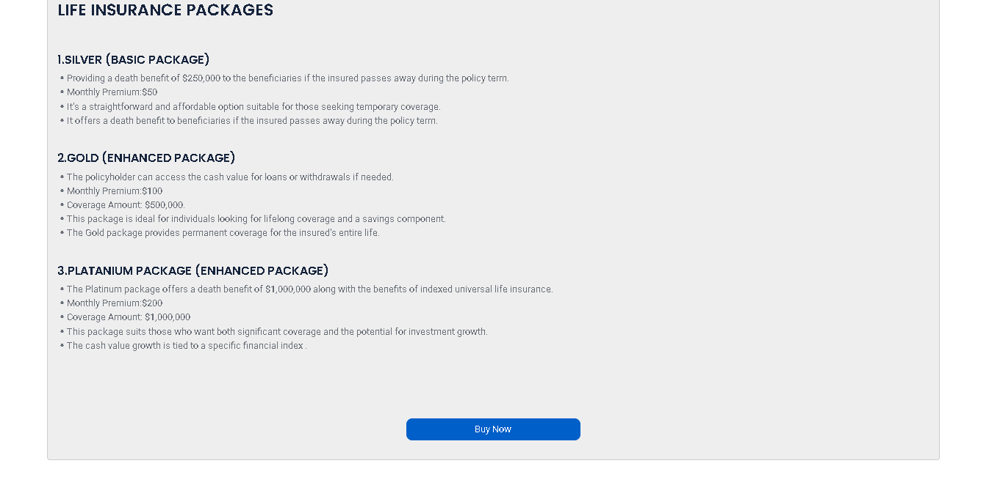

**“HEALTH INSURANCE DETAILS PAGE”**



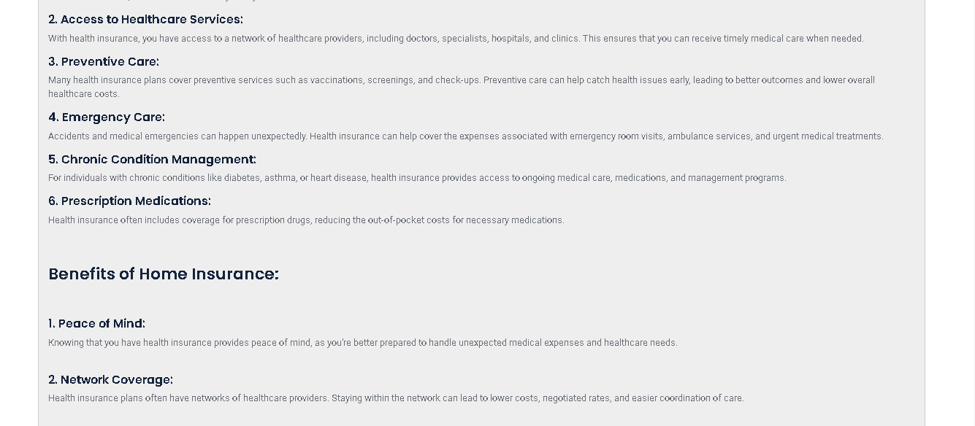

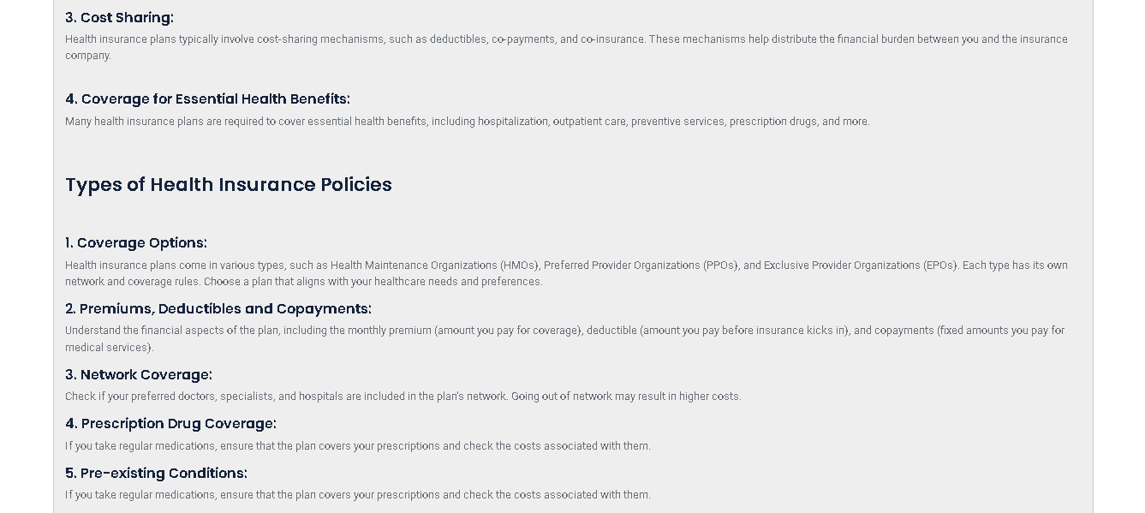

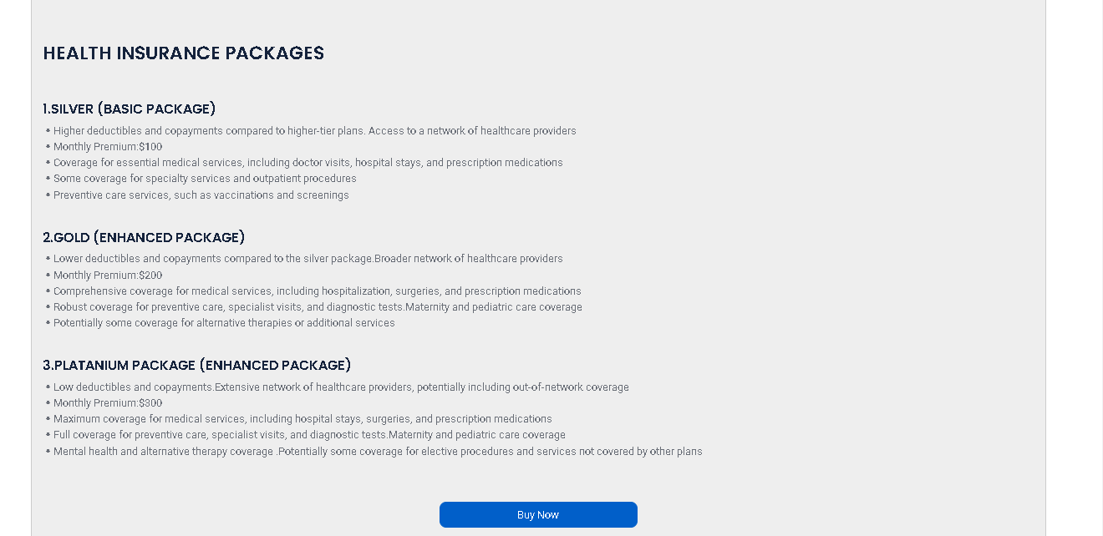

**“HOME INSURANCE DETAILS PAGE”**

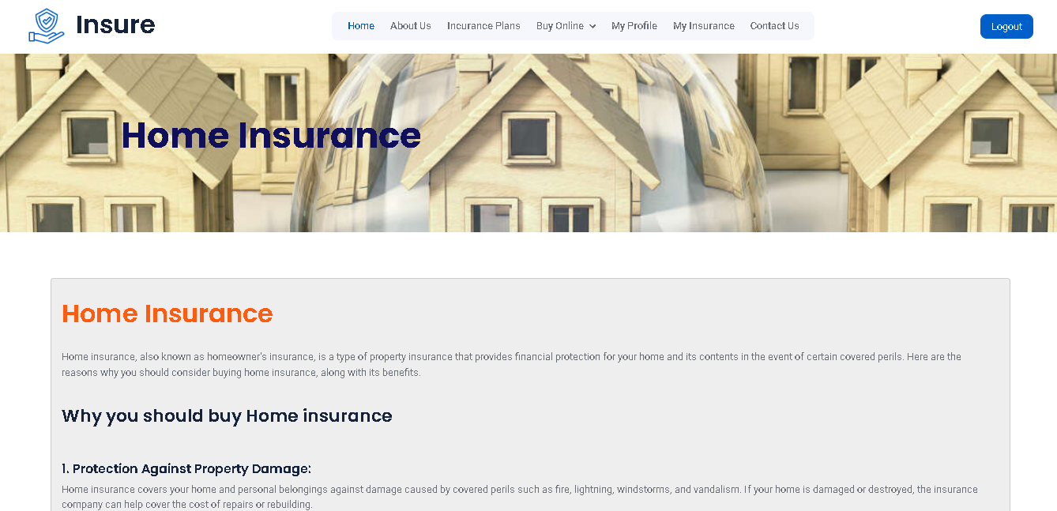

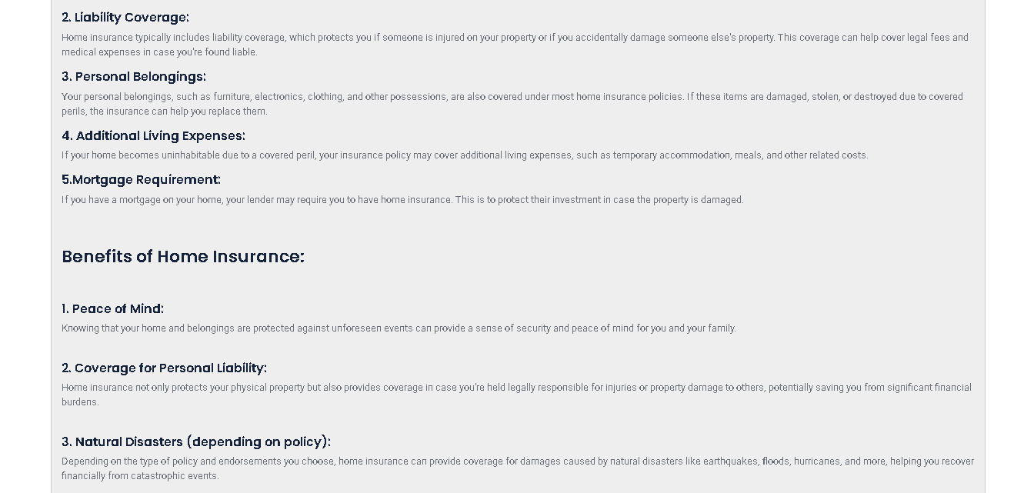

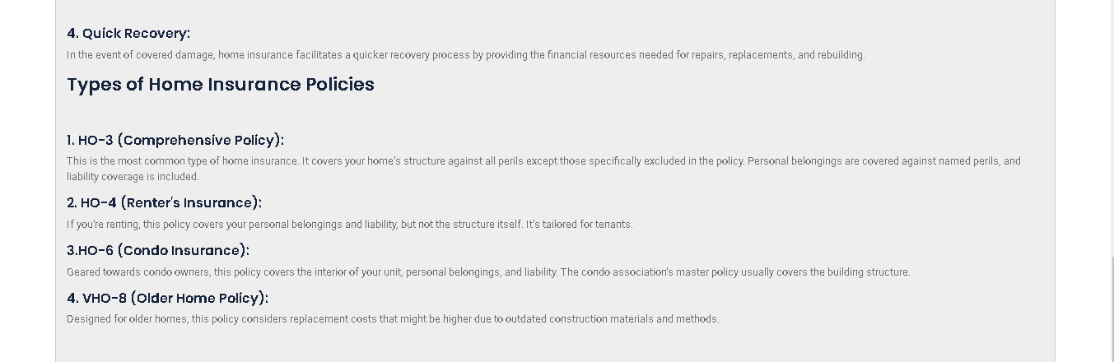

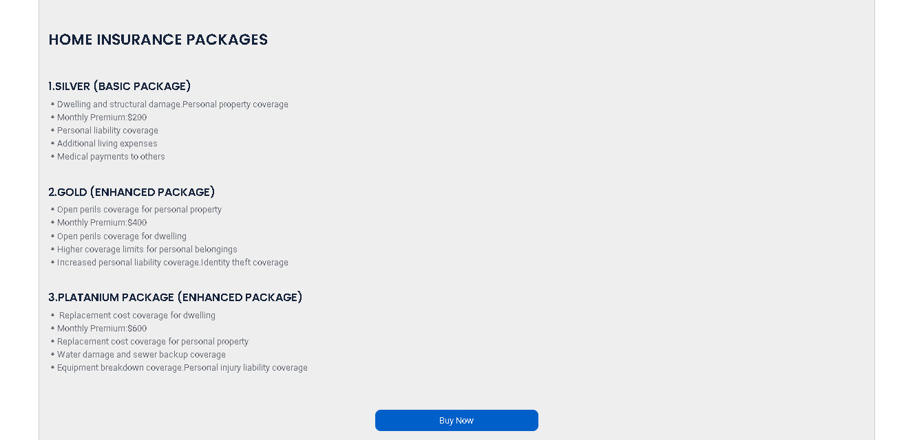

**“MOTOR INSURANCE DETAILS PAGE”**

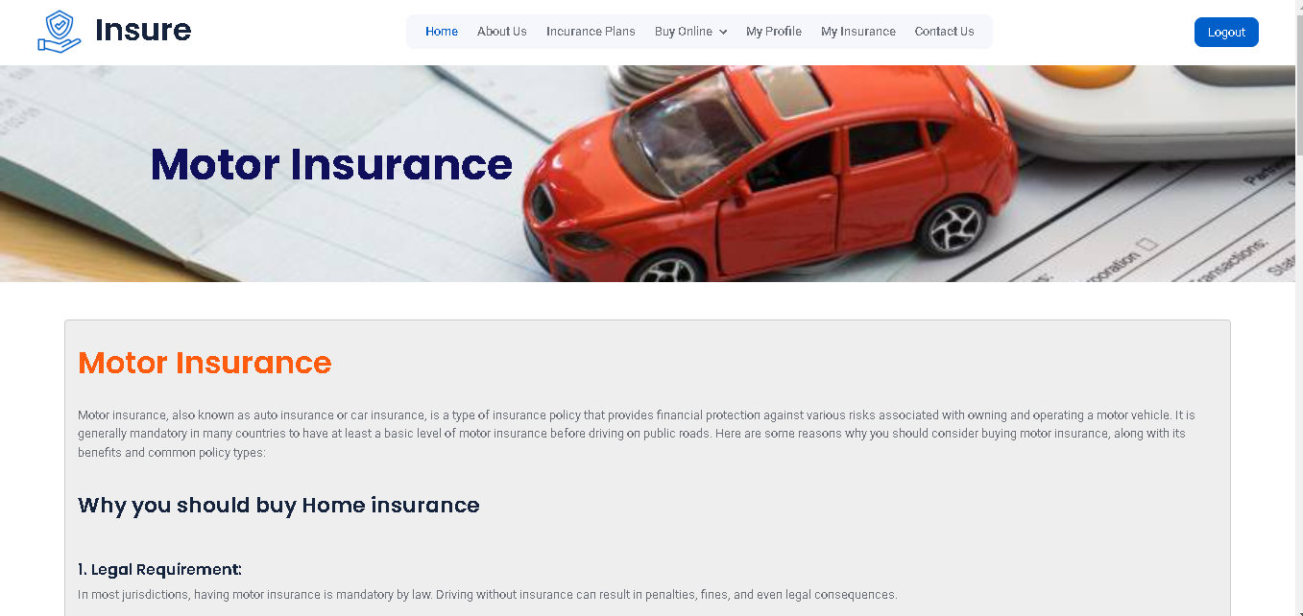

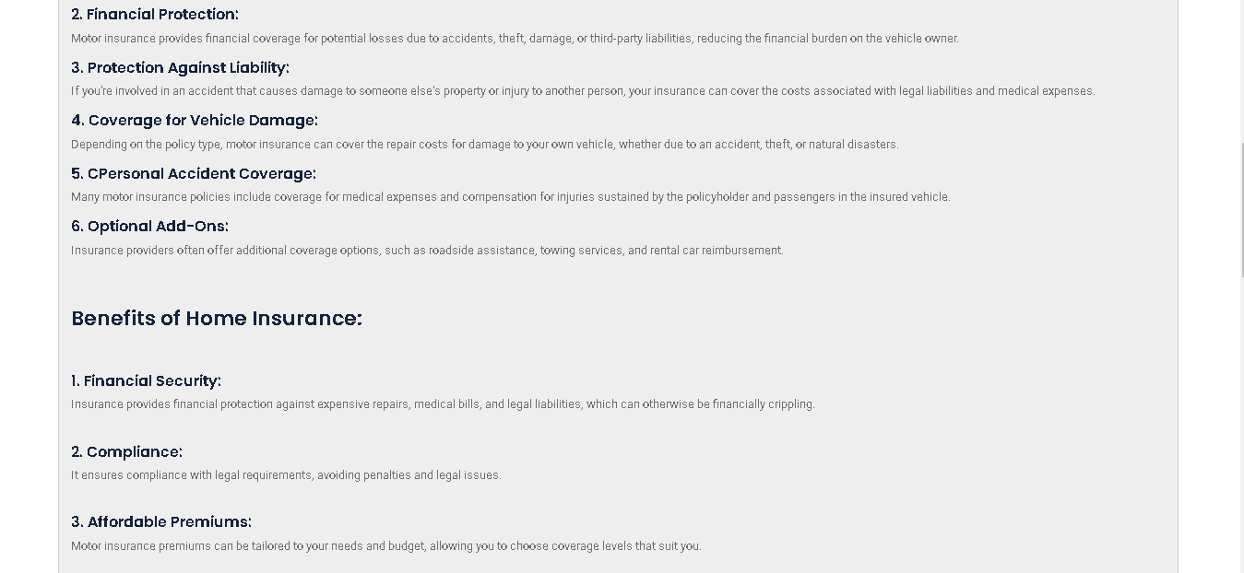

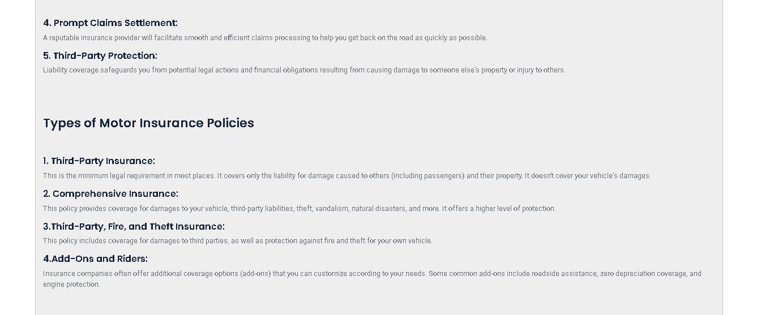

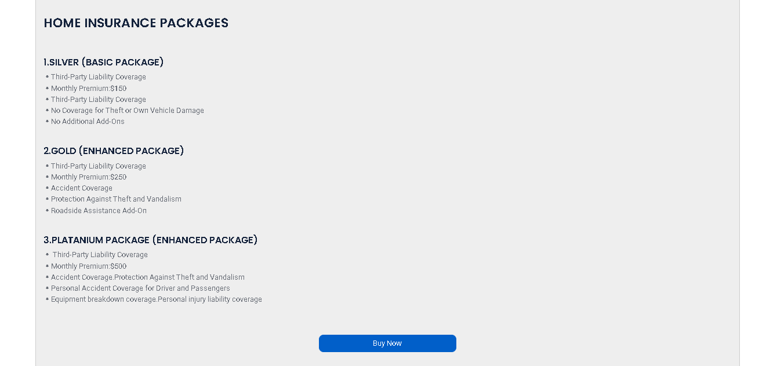

**“Section 4: BUY ONLINE AND ITS HAS INDIVIDUAL INSUARANCE PAGE”**

**“LIFE INSURANCE:”**

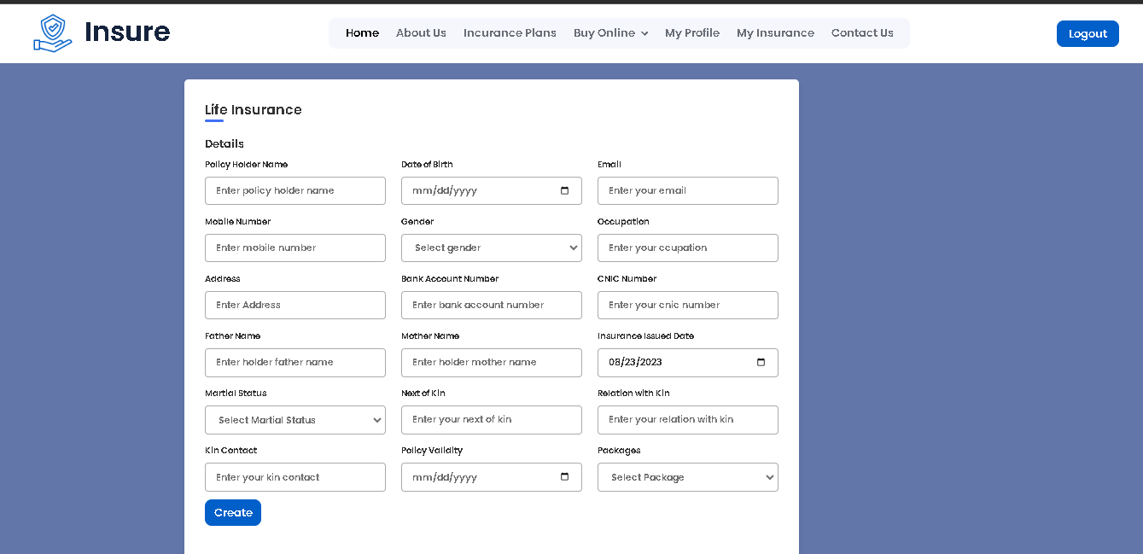

**“HEALTH INSURANCE:”**

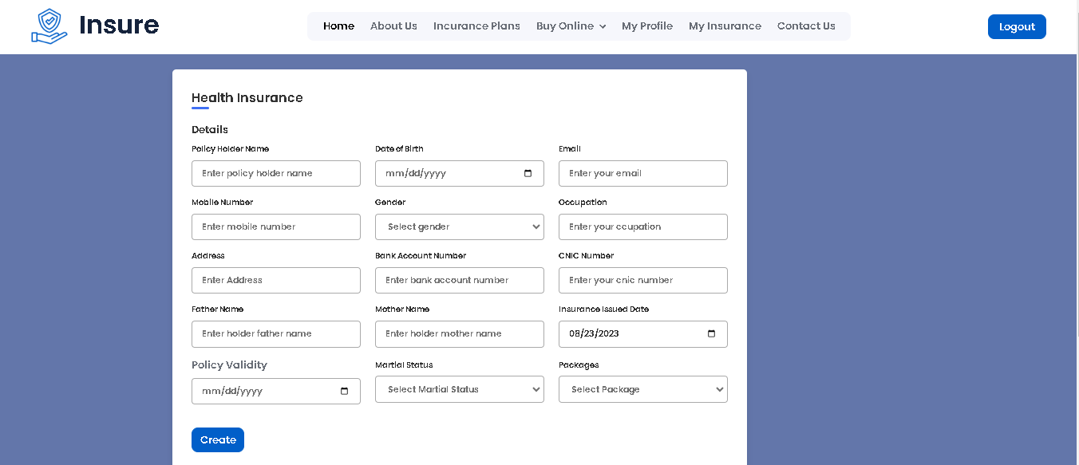

**“HOME INSURANCE:”**

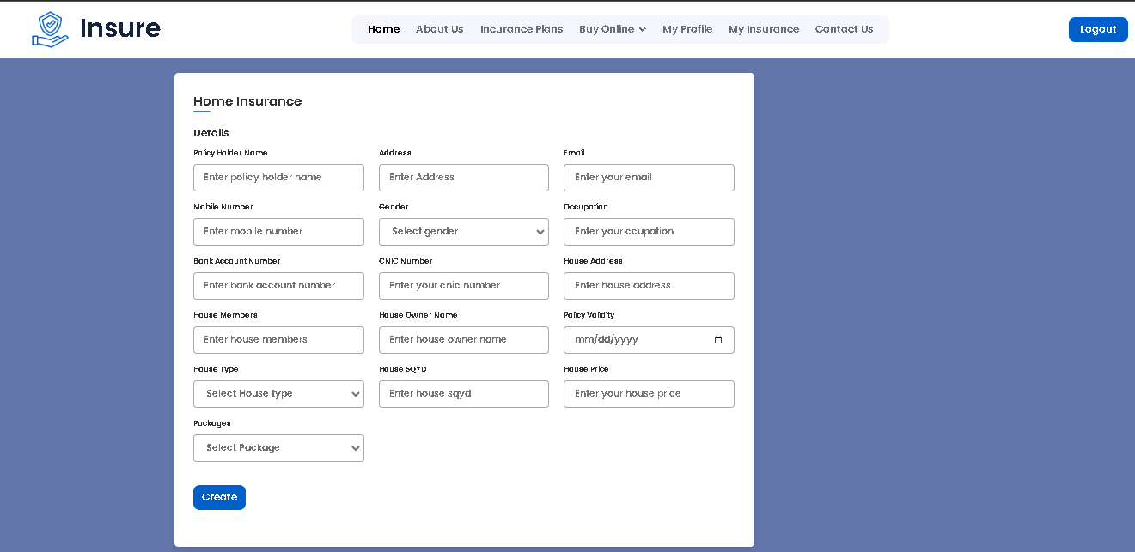

**“MOTOR INSURANCE:”**

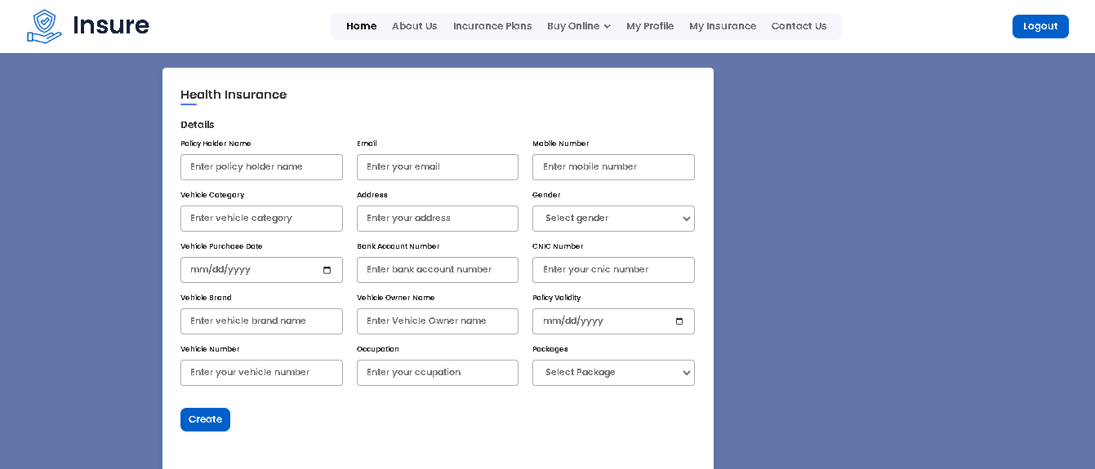

**“Section 4: ABOUT US”**







**“Section 5: CONTACT US”**

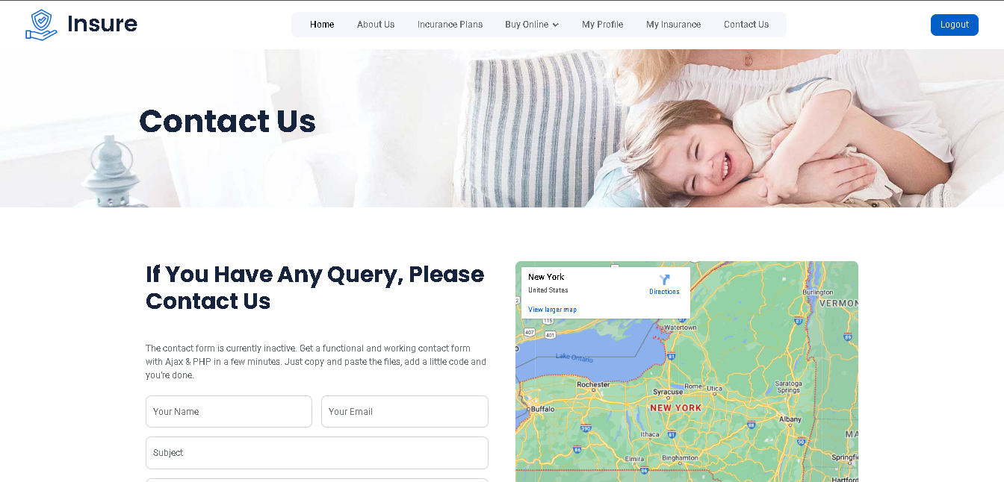

**ADMIN:**

**“Section 6: ADMIN Home Page”**







**“Section 7:LIFE INSURANCE ALL DETAILS”**

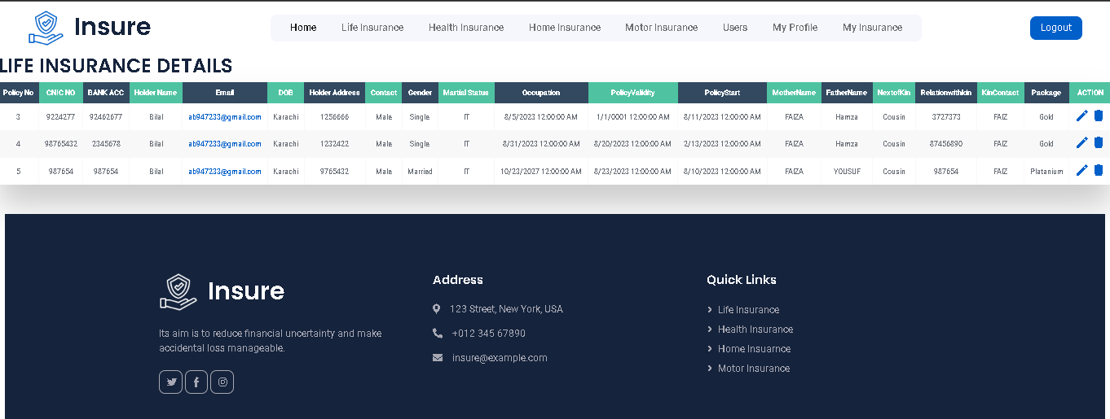

**“IT IS A DUMMY DETAILS”**

**“Section 7.1:LIFE INSURANCE EDIT DETAILS”**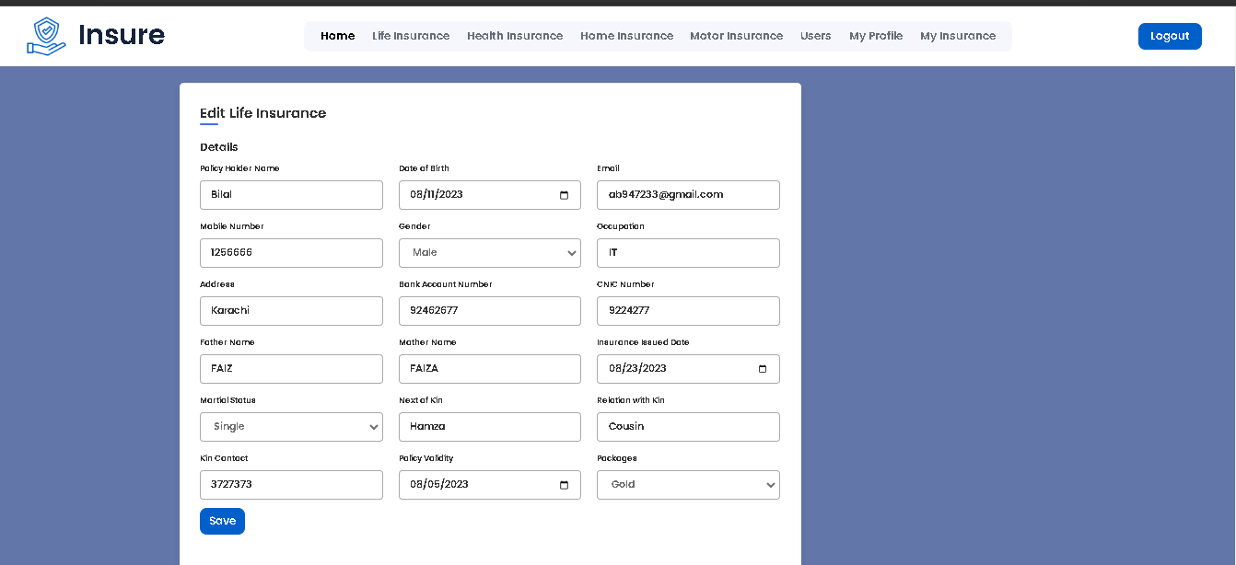

**“Section 8:HEALTH INSURANCE ALL DETAILS”**

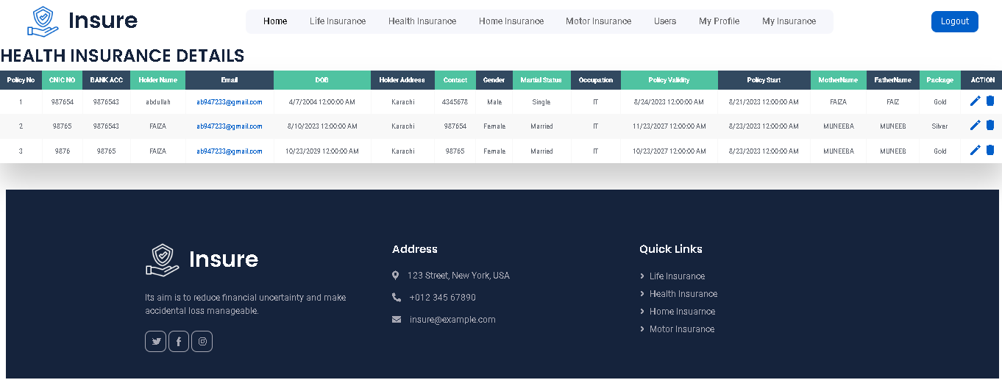

**“IT IS A DUMMY DETAILS”**

**“Section 8.1:HEALTH INSURANCE EDIT DETAILS”**

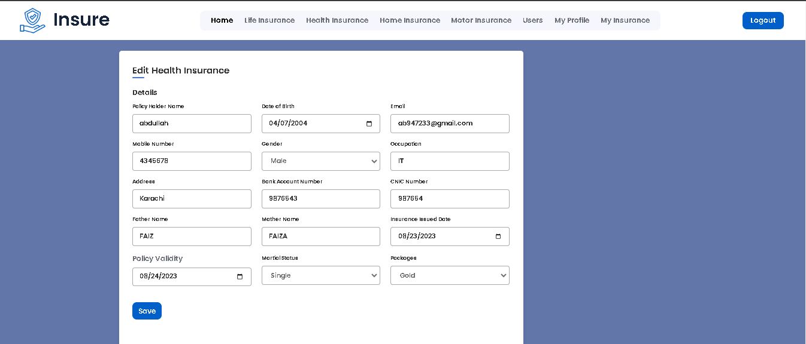

**“Section 9:HOME INSURANCE ALL DETAILS”**

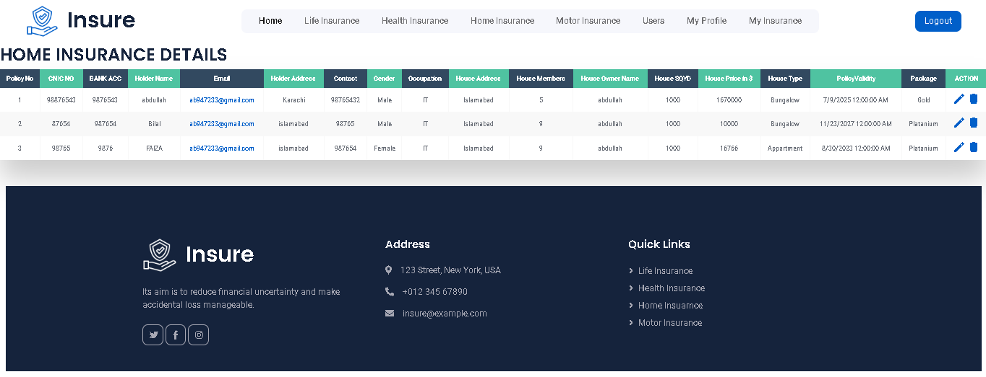

**“IT IS A DUMMY DETAILS”**

**“Section 9.1:HOME INSURANCE EDIT DETAILS”**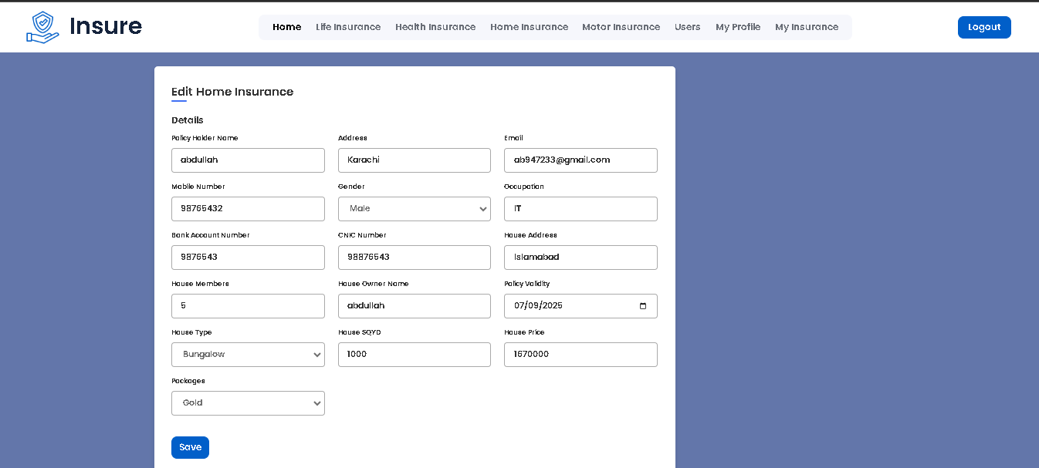

**“Section 10:MOTOR INSURANCE ALL DETAILS”**

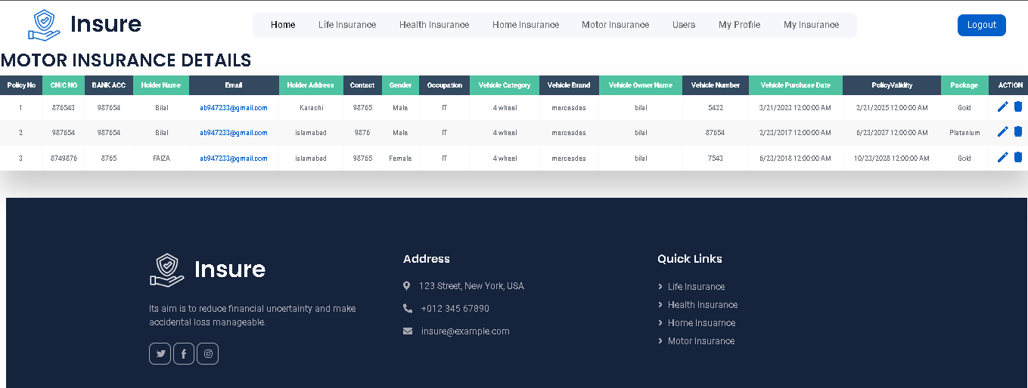

**“IT IS A DUMMY DETAILS”**

**“Section 10.1:MOTOR INSURANCE EDIT DETAILS”**

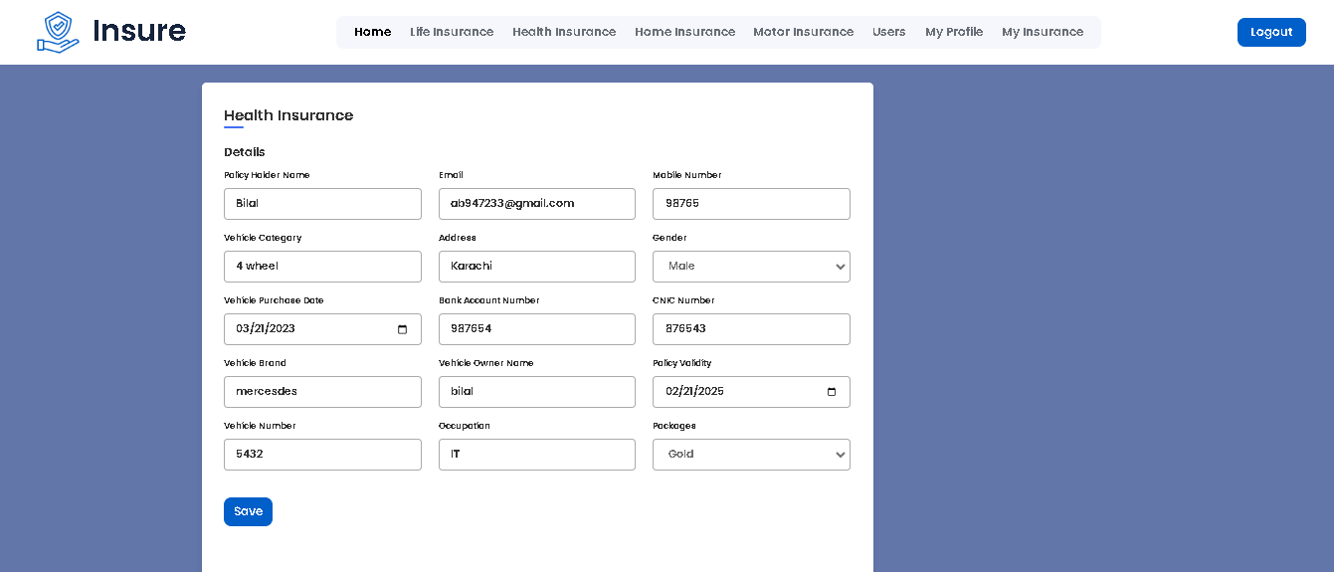

**“Section 10.1:USERS DETAILS”**

